
ALLIANCE UNIVERSITY
Alliance School of Advanced Computing

Student Name: BasavanaGowda S C
Register Number: PROV/ASAC/MCA/07/26/084
Project Name: Business and Financial Performance Analysis Using Exploratory Data Analytics and Interactive Power BI Visualization

ACADEMIC YEAR: 2026-2028

Department of Computer Applications

Program - Master of Computer Applications
Semester 1

ACKNOWLEDGEMENT
I would like to express my sincere gratitude to everyone who supported and guided me throughout the successful completion of this project.
I am thankful to my Project Guide for providing valuable guidance, suggestions, encouragement, and continuous support throughout the development of this project. I also express my gratitude to the faculty members and my institution for providing the necessary resources and a supportive learning environment.
I would also like to thank my friends and classmates for their cooperation and support during the completion of this project. Finally, I am deeply grateful to my family for their constant encouragement, motivation, and support.
I sincerely thank everyone who contributed directly or indirectly to the successful completion of this project.
Student Name: BasavanaGowda S C

Register Number: PROV/ASAC/MCA/07/26/084

Project Title: Business and Financial Performance Analysis Using Exploratory Data
Analytics and Interactive Power BI Visualization

Signature of Student

Signature of Faculty & Project Guide

Project Faculty & Project Guide Name: Oleti Durga Bravish
- Abstract:
Business and Financial Performance Analysis Using Exploratory Data Analytics and Automotive manufacturers generate large volumes of sales records across regions, vehicle types, models and sales channels, but raw tables rarely tell decision makers what is working and what is not. This project converts a 1,000-record global vehicle sales dataset (2016–2025) into an end-to-end analytics solution. The raw CSV was profiled and cleaned in a Python (pandas, NumPy, scikit-learn) Jupyter notebook: missing values and duplicates were checked, text fields were trimmed and validated, a Date field was derived from Year and Month, categorical fields were label-encoded, and numeric fields were standardised. The cleaned data was then loaded into Microsoft Power BI to build a two-page interactive dashboard (line, area, bar, column, donut, pie and scatter visuals), and into a lightweight browser-based dashboard built with HTML and Chart.js that supports CSV import, region and channel filters, automatic written insights, an editable data table and CSV export.
The analysis covers 1,290,667 units sold, USD 53.57 billion in revenue and USD 8.40 billion in profit (an overall margin of about 15.7%). Key findings: Latin America is the highest-revenue region (USD 9.62 billion) and Asia the lowest (USD 8.41 billion); Fleet is the strongest sales channel in both revenue and profit; Pickup is the leading vehicle type and SUV the weakest; Corolla is the top-selling model; and annual revenue is cyclical rather than steadily growing. The project shows how a structured pipeline of cleaning, validation and visualisation can turn a flat file into actionable business insight.
Keywords: Sales analytics, Power BI, data cleaning, pandas, dashboard, automotive sales, Chart.js

- Introduction:
Data-driven decision making is now central to the automotive industry. Sales leaders must decide which regions deserve more investment, which channels deliver the best returns, which vehicle types and models to promote, and how profitability is moving over time. Answering these questions requires data that is accurate, consistent and presented in a form that non-technical stakeholders can explore.
This capstone project addresses that need for a manufacturer-style sales dataset covering six regions, six vehicle types, eight models and four sales channels over ten years. The work is divided into three stages:
- Data understanding and preparation in a Jupyter notebook using Python.
- Business intelligence reporting in Microsoft Power BI Desktop.
- A custom, browser-based dashboard written in HTML, CSS and JavaScript that works offline with any compatible CSV.
The objective is not only to draw charts but to build a repeatable workflow: raw data goes in, validated and encoded data comes out, and interactive visuals and written insights are produced from it.

2.1 Objectives
- Inspect the raw dataset for completeness, duplicates, data-type problems and inconsistent text.
- Validate the financial logic of the data (Revenue = Units × Price; Profit = Revenue − Cost − Operating Expenses).
- Prepare an analysis-ready dataset with a date field, encoded categories and scaled numeric features.
- Build interactive Power BI dashboards for revenue, profit, units, region, channel, vehicle type and model analysis.
- Build a lightweight web dashboard with KPIs, filters, charts and auto-generated sales commentary.
- Summarise findings and recommendations for business stakeholders.
2.2 Scope
The project covers descriptive and diagnostic analytics (what happened and where). It does not include forecasting or causal modelling, although the encoded and scaled dataset has been prepared so that such models can be added later.

- Problem Statement:
Sales data in its raw form is a flat table of 1,000 rows and 15 columns. In that form it is difficult to see regional differences, channel performance, trends over time or the relationship between volume, price and profit. Several practical problems follow:
- Fragmented insight. Managers must filter and pivot manually in spreadsheets to answer even basic questions, which is slow and error-prone.
- Data quality risk. Without systematic checks, inconsistent text (extra spaces, variant spellings), duplicate rows, missing values or broken financial relationships can silently distort totals and averages.
- Scale mismatch. Variables such as Revenue_USD (millions) and Customer_Satisfaction (1–5 scale) are on very different scales, which makes comparison and any later machine-learning use difficult without scaling.
- Limited accessibility. Static reports cannot be filtered by region or channel, and stakeholders without BI licences cannot open Power BI files.
- No automatic narrative. Charts alone do not tell a reader what the numbers mean; a written summary is needed each time the data changes.
Problem statement: To design and implement a reliable analytics pipeline that cleans and validates global vehicle sales data, and presents revenue, profit, unit sales, regional, channel, vehicle-type and model performance through interactive dashboards and automatically generated insights, so that business users can make faster and better-informed decisions.

- Existing System:
In the existing approach, sales data is kept in a CSV or Excel file and analysed manually.
Aspect | Existing system
Data handling | Manual opening and filtering of CSV/Excel sheets
Data quality checks | Informal, often skipped; duplicates and inconsistent text can go unnoticed
Calculation validation | No automated check that Revenue = Units × Price or Profit = Revenue − Cost − OpEx
Visualisation | Static charts created by hand, rebuilt whenever data changes
Interactivity | Little or none; each question needs a new pivot table
Insight generation | Written manually by an analyst
Sharing | Files emailed around; version confusion is common
Scalability | Becomes slow and error-prone as rows and dimensions grow

4.1 Limitations of the Existing System
- Time-consuming and dependent on individual spreadsheet skills.
- High risk of human error in formulas and aggregations.
- No consistent data-cleaning procedure, so results are hard to reproduce.
- No drill-down by region, channel, model or year without rebuilding reports.
- Absence of a unified view of KPIs such as revenue, profit, units and margin.
- Data is not prepared for advanced analytics or machine learning (no encoding or scaling).

- Proposed System:
The proposed system is a three-layer analytics solution that automates preparation, supports interactive exploration and communicates findings in plain language.
5.1 Layer 1 – Data Preparation (Python / Jupyter)
The notebook performs the following steps in order:
- Load ADST_PROJECT.csv with pandas and inspect shape (1000 × 15), head, tail, info() and describe().
- Quality checks: missing values per column (none found) and duplicate rows (none found); drop_duplicates() applied as a safeguard.
- Date creation: a Date column is built from Year and Month, and the data is sorted chronologically with the index reset.
- Categorical encoding: one-hot encoding (get_dummies, drop_first) for Region, Vehicle_Type, Model and Sales_Channel, plus label-encoded columns (Region_Encoded, Vehicle_Type_Encoded, Model_Encoded, Sales_Channel_Encoded).
- Scaling: StandardScaler applied to nine numeric columns (Units_Sold, Average_Price_USD, Revenue_USD, Cost_USD, Operating_Expenses_USD, Profit_USD, Profit_Margin_Percent, Market_Share_Percent, Customer_Satisfaction), giving mean ≈ 0 and standard deviation ≈ 1.
- Text standardisation: leading and trailing spaces removed from the four text columns, and unique values listed to confirm consistent labels.
- Export: the result is saved as ADST_PROJECT_cleaned.csv (1,000 rows × 20 columns).
5.2 Layer 2 – Power BI Dashboard
The cleaned dataset is loaded into Power BI Desktop. A two-page report (1920 × 1080 canvas, Fluent 2 theme) presents:
- Revenue and profit trends by year (line and area charts).
- Revenue and profit by region (pie chart) and by sales channel (donut chart).
- Units sold, revenue and profit comparisons (clustered bar and column charts).
- Vehicle type by sales channel (column chart) and model performance (scatter chart).
- Text boxes that carry titles and explanatory notes.
5.3 Layer 3 – Browser-Based Sales Dashboard (HTML / CSS / JavaScript)
A self-contained web page, "Sales Analytics", lets any user import a CSV and instantly see:
- Four KPI cards: Total Revenue, Total Profit, Units Sold and Profit Margin.
- Region and Sales Channel drop-down filters that update everything on screen.
- Six Chart.js charts: Revenue by Region, Revenue by Year, Profit by Year, Profit by Sales Channel, Region by Sales Channel and Vehicle Type by Sales Channel.
- An auto-generated Sales Analysis panel that rewrites its text whenever the data or filters change.
Existing system | Proposed system
Manual cleaning | Reproducible, scripted cleaning and validation
Existing system | Proposed system
Static charts | Interactive, filterable dashboards
Separate files for each view | One KPI view with drill-down by region, channel, year and model
Analyst writes commentary each time | Insights generated automatically
Unsuitable for ML | Encoded and scaled data ready for modelling
Needs BI licence to view | Web dashboard runs in any modern browser
5.4 Advantages of the Proposed System

- About Dataset:
The dataset (ADST_PROJECT.csv) contains 1,000 records and 15 columns of vehicle sales from January 2016 to December 2025. Each row is a monthly sales record for one combination of region, vehicle type, model and sales channel. There are no missing values and no duplicate rows.

  - Data Dictionary
 | Column | Type | Description
1 | Year | Integer | Sales year (2016–2025)
2 | Month | Integer | Sales month (1–12)
3 | Region | Text | Asia, Europe, Japan, Latin America, Middle East, North America
4 | Vehicle_Type | Text | EV, Hatchback, Hybrid, Pickup, SUV, Sedan
5 | Model | Text | Camry, Corolla, Fortuner, Hilux, Land Cruiser, Prius, RAV4, Yaris
6 | Sales_Channel | Text | Corporate, Dealer, Fleet, Online
7 | Units_Sold | Integer | Number of vehicles sold (85–2,498)
8 | Average_Price_USD | Integer | Average selling price (USD 18,060–64,900)
9 | Revenue_USD | Integer | Units sold × average price
10 | Cost_USD | Decimal | Cost of goods sold
 | Column | Type | Description
11 | Operating_Expenses_USD | Decimal | Operating expenses
12 | Profit_USD | Decimal | Revenue − Cost − Operating expenses
13 | Profit_Margin_Percent | Decimal | Profit as a percentage of revenue (0.27–  30.62)
14 | Market_Share_Percent | Decimal | Market share (2.0–19.5)
15 | Customer_Satisfaction | Decimal | Rating on a 1–5 scale (2.5–5.0)

  - Summary Statistics (raw data)
Measure | Mean | Minimum | Maximum
Units_Sold | 1,290.7 | 85 | 2,498
Average_Price_USD | 41,322 | 18,060 | 64,900
Revenue_USD | 53.57 million | 2.78 million | 156.52 million
Profit_USD | 8.40 million | 0.10 million | 36.89 million
Profit_Margin_Percent | 15.81 | 0.27 | 30.62
Market_Share_Percent | 10.06 | 2.00 | 19.50
Customer_Satisfaction | 4.09 | 2.50 | 5.00

  - Data Validation Findings

Revenue check: on the raw data, Revenue_USD equals Units_Sold × Average_Price_USD exactly for all 1,000 rows (difference of zero).
Profit check: Profit_USD equals Revenue − Cost − Operating Expenses to within USD 0.01 on every row (rounding only).
Note: in the notebook these two checks were run after the numeric columns had been standardised, so they show non-zero values (for example a standard deviation of about 1.2 and 1.75). That is a side effect of scaling, not a data error, and the checks should be run before scaling.
Categories: all four text columns contain consistent, clean labels after trimming.

  - Cleaned Dataset

ADST_PROJECT_cleaned.csv has 20 columns: the original 15, plus Date and four encoded columns. Its numeric fields are standardised (z-scores). Because of this, charts built in Power BI directly on the cleaned file display scaled values, so original-unit figures (USD) should be used for reporting totals.

- Technologies Used:
Category | Technology | Purpose in the project
Programming language | Python 3 | Data cleaning, validation and preparation
Data libraries | pandas, NumPy | Loading, inspecting, grouping and transforming data
Machine-learning  utilities | scikit-learn (LabelEncoder, StandardScaler) | Categorical encoding and numeric scaling
Environment | Jupyter Notebook | Interactive, documented analysis (exported to HTML/PDF)
BI tool | Microsoft Power BI Desktop | Interactive dashboards (.pbix) with DAX/date hierarchy
Web technologies | HTML5, CSS3, JavaScript | Custom browser dashboard layout, styling and logic
Charting library | Chart.js (via CDN) | Bar, line, doughnut and stacked charts in the browser
Data format | CSV | Raw, cleaned and exported data
Hardware / OS | Windows PC | Development platform

  - Why These Tools
pandas and NumPy provide fast, readable data manipulation for a dataset of this size. scikit-learn gives standard, well-tested encoders and scalers that make the data ready for future modelling.
Power BI offers drag-and-drop interactivity, cross-filtering and professional layouts with little code.
HTML/JavaScript with Chart.js provides a free, licence-less alternative that anyone can open in a browser, with the added ability to import CSVs, edit rows, generate insight text and export results.

- Data Flow Diagram:
(The data flow diagram is shown below and described in this section.)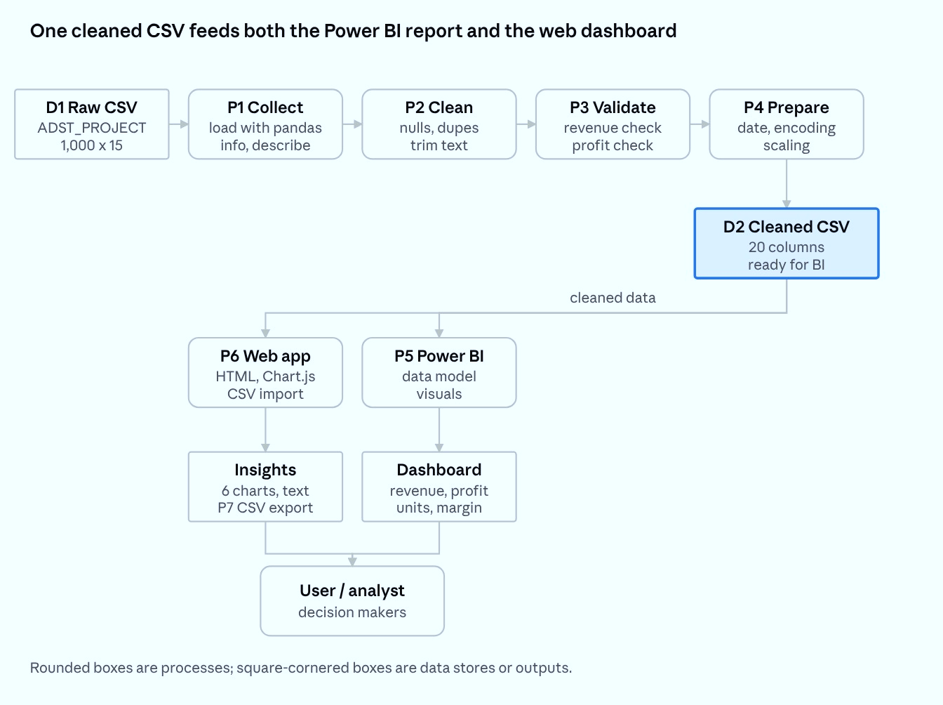
This data architecture pipeline begins by taking raw data from a 1,000-by-15 CSV file and running it through a four-stage ETL process in Python using pandas—collecting and inspecting the structure, cleaning nulls and duplicates, validating core metrics like revenue and profit, and preparing standardized date and scaled fields—to produce a single, unified 20-column dataset. From this centralized source of truth, the clean data concurrently feeds two separate reporting paths: a custom web application using HTML and Chart.js that generates interactive charts and CSV exports, and a Power BI platform that models the data into key business dashboards tracking revenue, profit, units, and margin. Ultimately, both paths deliver consolidated visual insights to analysts and decision-makers to support data-driven strategy.

- Output:
This pie chart displays total revenue (in USD) broken down by region, showing Asia taking the majority share at 52.95% ($21.41M) and Latin America accounting for the remaining 47.05% ($19.02M)
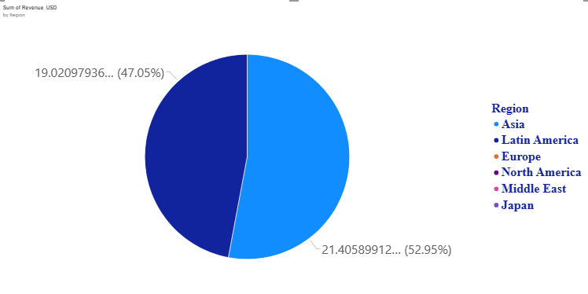
Fig 1: Sum of Revenue by USD By Region

This area chart tracks total revenue (in USD) by year from 2016 through 2025, highlighting major positive peaks around 2018 and 2023, along with significant downturns around 2021 and 2024.
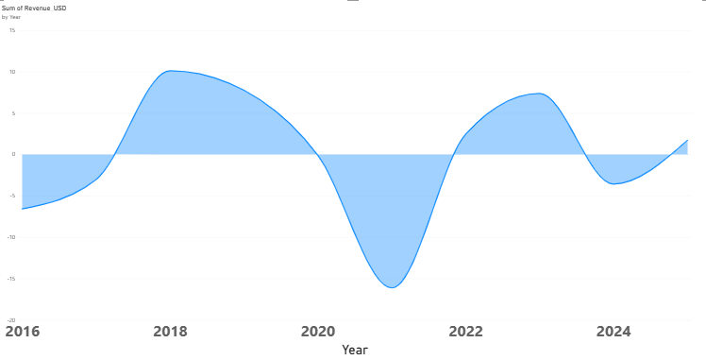
Fig 2: Sum of Revenue By USD By Year

This line chart shows total profit (in USD) by year from 2016 to 2025, highlighting sharp surges peaking around 2019 and 2023 alongside notable dips around 2021 and post-2023.

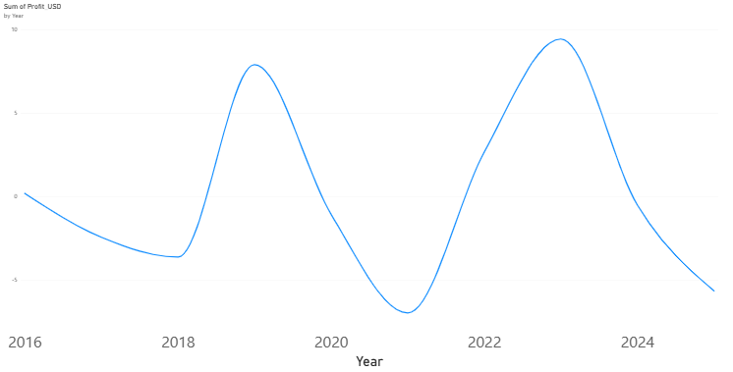
Fig 3:Sum of Profit USD By Year

This donut chart shows total profit (in USD) by sales channel, with Fleet generating the vast majority at 90.64% ($16.94M) and Online accounting for the remaining 9.36% ($1.75M).
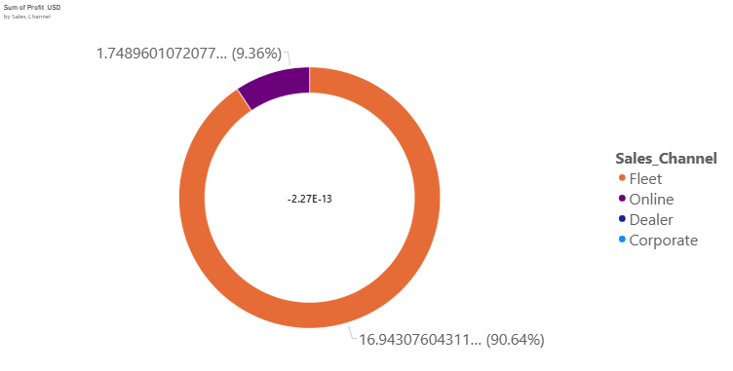
Fig 4: Sum of Profit USD By Sales Channel

This horizontal bar chart displays the count of region entries across various negative Revenue USD values color-coded by Sales Channel (Corporate, Dealer, Fleet, and Online), where each individual revenue bin registers a count of 1.
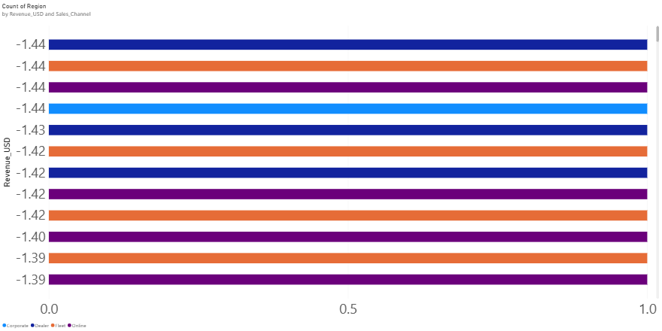
Fig 5: Count of Region By Revenue USD and Sales Channel
This horizontal bar chart illustrates the sum of encoded sales channels across scaled units sold bins, showing encoded channel 3 (purple) consistently reaching a value of 6 across all three levels, accompanied by smaller contributions from channel 2 (orange, value of 4) at 0.50 units and channel 1 (blue, value of 1) at -1.51 and -1.21 units.
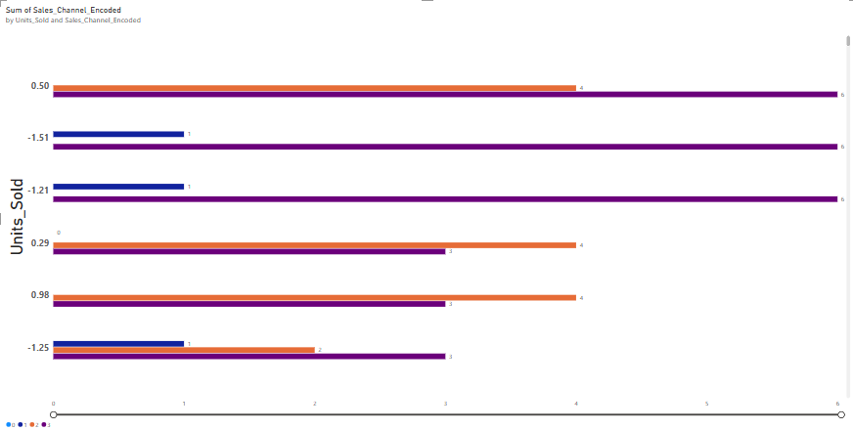
Fig 6: Sum of Sales Channel Encoded

This Sales Intelligence web dashboard displays executive KPIs for the filtered Europe/Dealer segment—highlighting $5 Total Revenue, $12 Total Profit, 4.568 Units Sold, and a 248.1% Profit Margin alongside Revenue by Region, Revenue by Year, and Profit by Year trend charts.
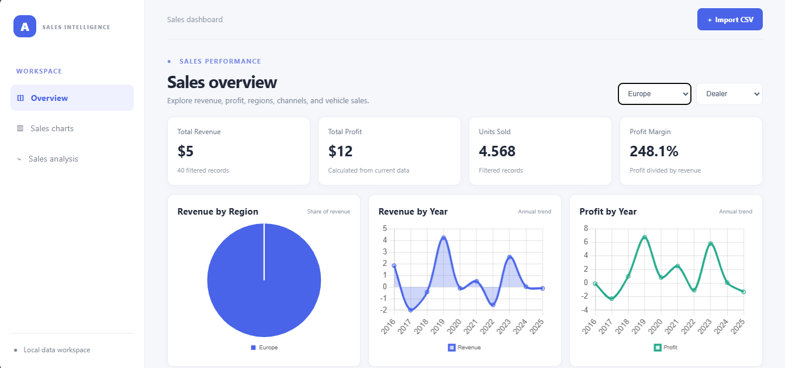
Fig 7: overview screen of a Sales Intelligence analytics dashboard
This Sales Analysis view provides auto-generated key insights alongside an interactive, editable table displaying the underlying 40 sales records with metrics like revenue, cost, operating expenses, and profit.
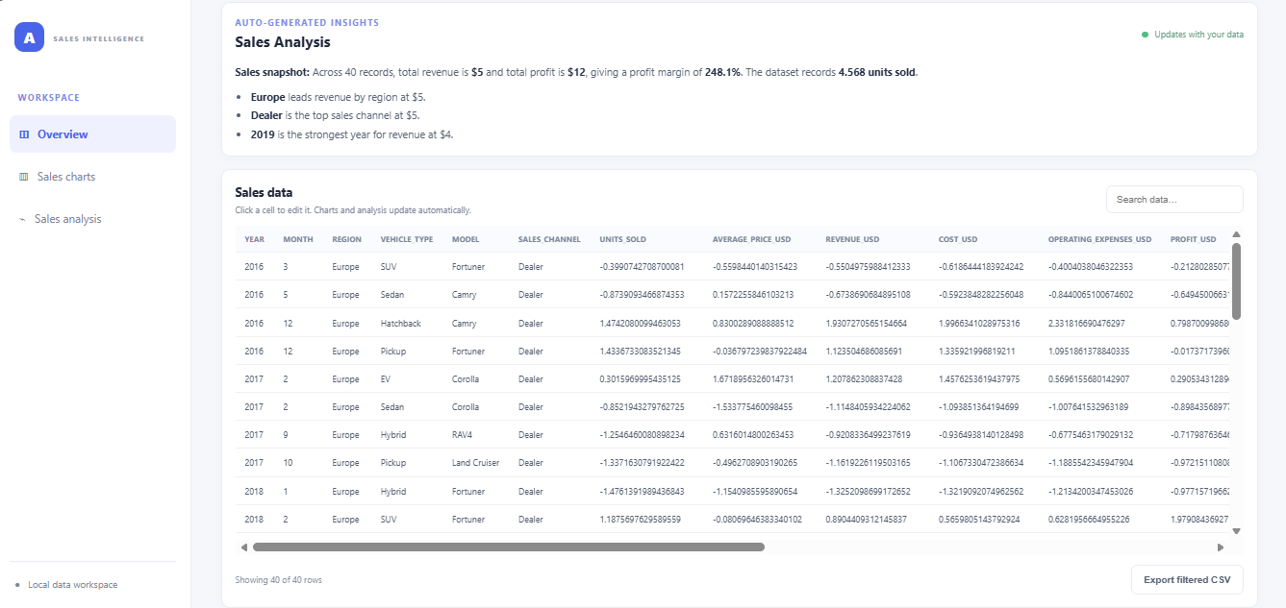
Fig 8: Sales Analysis & Data Table

- Conclusion:
This project successfully built a complete analytics workflow for global vehicle sales data. The notebook confirmed that the 1,000-row dataset is complete and duplicate-free, that its financial fields are internally consistent, and then produced an encoded and standardised version suitable for BI and future modelling. Power BI delivered an interactive two-page dashboard, and the custom HTML dashboard provided a free, portable alternative that also writes its own commentary.
10.1 Key Findings
- Total sales were 1.29 million units, USD 53.57 billion in revenue and USD 8.40 billion in profit, a margin of roughly 15.7%.
- Latin America is the top region by revenue, units and profit; Asia has the lowest revenue and units.
- Fleet is the leading channel for revenue and profit; Dealer is the weakest.
- Pickup is the leading vehicle type; SUV is the weakest.
- Corolla leads on revenue and units, Fortuner on profit; Prius and Yaris lag.
- Annual revenue fluctuates between USD 4.3 and 6.3 billion with no consistent upward trend.
10.2 Recommendations
Strengthen Fleet and Online sales programmes, and review Dealer cost and incentive structures.
Investigate why Asia underperforms in volume given its market size.
Review the SUV range and the Prius and Yaris positioning.
Study the alternating strong and weak years to find seasonal or product-cycle causes.

